Renju lesson on February 15, 2001

Hello all! Welcome to Online Renju Class. We will begin the lesson. As the d8 opening is one of the most important and most popular openings, we will introduce several ideas for you. Last week we learned about white 24-e7. Today we will learn about 24-i11. That move was quite popular in the old times, but actually black wins there. We will learn the ideas how to win here. Can you guess the black winning area? Is it left side, right side, upper or lower side? Suppose we want to win on the lower side, should we worry about white active material? If black simple plays to the right lower side, then white can take the e8 point and perhaps develop some active structures on lower side too. Yes, black should begin with taking care of white material first. Black plays moves e7, e8 and neutralizes the left side. Move 28-g6 is an active defense. It blocks the left side completely and does not let black connect left and right sides. Black uses all his left side material to eliminate white structures. That’s the only purpose of left side material. Black knows that if the white structures are dead, then the right side material is enough for win. White moves g5 and f5 are the strongest – they are enough to block the left side, and they are as close to the right side as possible to help to block something about right side too. That is why they are better than simple defense to d8 or something. Move 33-e5 is the last preparation move. After that move all the white structures are dead, and black continues according to the plan – winning attack on the right side. How does black begin the winning attack?
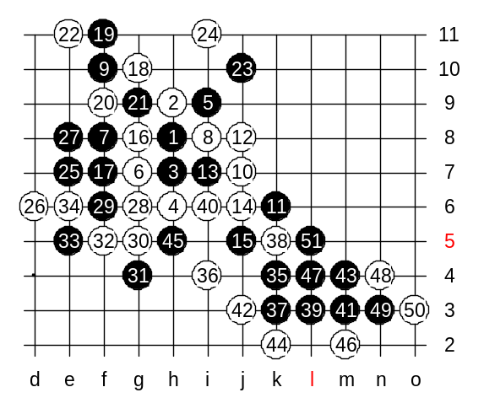
Some of you suggest k4, some of you suggest first i4, then k4. Which choice is more correct? Do you remember I told you long time ago, never play any three or four unless you have to. You do not need to play i4 too early if white cannot block at i4 anyway in case of black’s k4. Playing a three too early just creates an additional white stone (h3) and that might make attack more difficult. Although I believe that in this case i4, k4 is win too, but it is more correct to play simple k4 if we are sure that white cannot block at i4 after that.
Lets play k4, and test white’s move to i4, to be sure that black wins. I am sure you can show me win here. Yes, quite easy win.
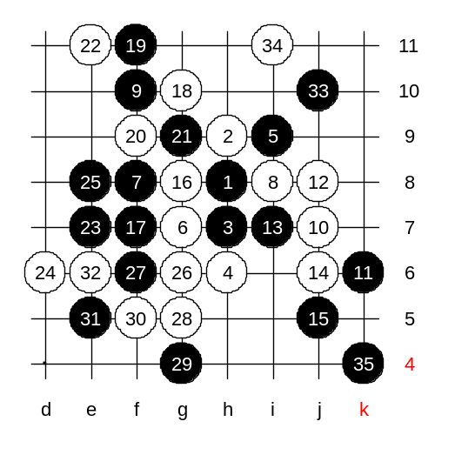
You saw that black win was quite simple after white structures had been blocked. Some of you mentioned the edge matters. Note that in case of rotated 5th move, the space in the corner is even bigger. The conclusion is that the 24th move loses. Now, some of you may have a question, if black’s e7 and e8 are so good, then could it be possible to play 23-e7, 24-d6, 25-e8 and reach to similar position as we just studied? Why does black need that j10 point anyway?
As you see, we changed the sequence of moves, and finally came to the same position as on previous diagram. That may keep you wondering, why did we need to learn about difficult 23-j10 and 24-e7 last week when this is so easy solution for win. Actually, this 23rd move, 23-e7, was also played many times in the past. And black won lots of games just as shown on this diagram. But the truth is, if white plays 24-h10, then according to the recent years analyses we can say that white practically wins.

Lets see how it happens.
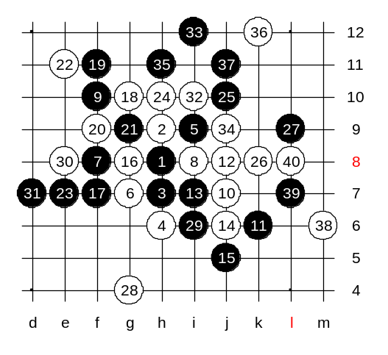
Black block 27-L9 was considered to be good defense 4 years ago. However, about 3 years ago, Russians found the sure white win here. Instead of traditional 28-h11, they used another idea. They began with 28-g4.
Who can first guess the only winning move for white? Wow, it took you long time to guess e8. Now, after having 31 stones on the board, some of you may recognize the renju problem that was published in the renju problem file. Yes, 32-i10 is the winning move. Now black has no escape from 3x3 or 4x4. Now you see why white could not play h11.

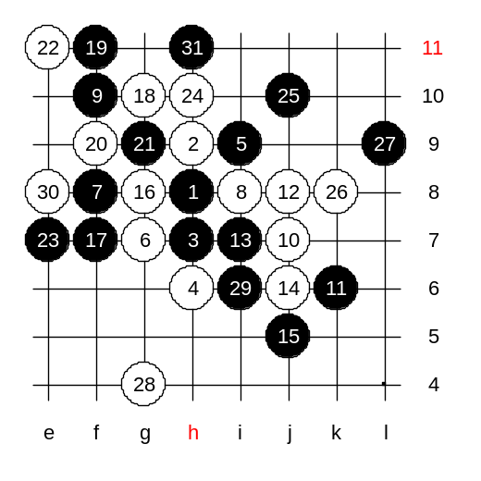
This is the medium level homework. Please find the white win.

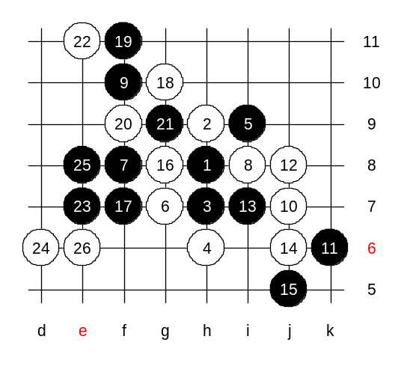

This is the advanced level homework. Please find the black win.

